CHAPTER 5 – FLOW CONTROL STATEMENTS, DECISION MAKING STATEMENTS &
LOOPING STATEMENTS
TOPICS COVERED
5.1 FLOW CONTROL STATEMENTS
5.1.1. BREAK STATEMENT
5.1.2. CONTINUE STATEMENT
5.1.3. PASS STATEMENT
5.2 DECISION MAKING STATEMENTS
5.2.1. IF STATEMENT
5.2.2. IF…ELSE STATEMENT
5.2.3. IF…ELIF…ELSE STATEMENT
5.3 LOOPING STATEMENTS
5.3.1. FOR LOOP
5.3.2. WHILE LOOP
5.4 PATTERN PROGRAM EXAMPLES

5.1 FLOW CONTROL STATEMENTS
Flow control statements in python are used to control the programs execution flow normally.
There are,
- Break statement
- Continue statement
- Pass statement
5.1.1. BREAK STATEMENT
- Break statement is used to terminate the loop execution and comes out of the loop when certain test condition is met and fulfilled.
- Break statement usually closes the opened indentation part with in a program.
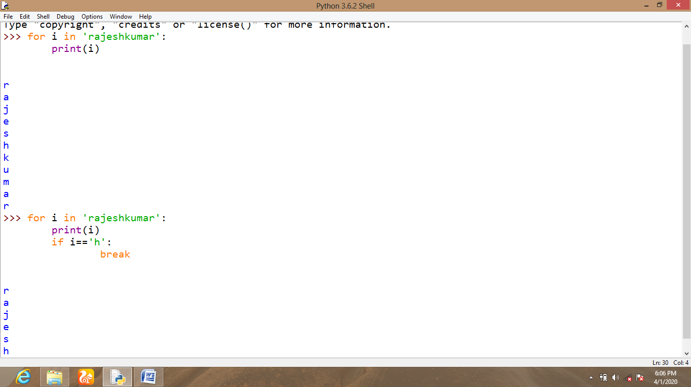
CONTINUE STATEMENT
Continue statement usually check the given test condition and instead of terminating the loop execution, this statement pause the loop execution and comes out of the loop then it resumes the remaining program execution from next element of the ongoing loop iteration.
This statement is also used to close the opened indentation in a program.
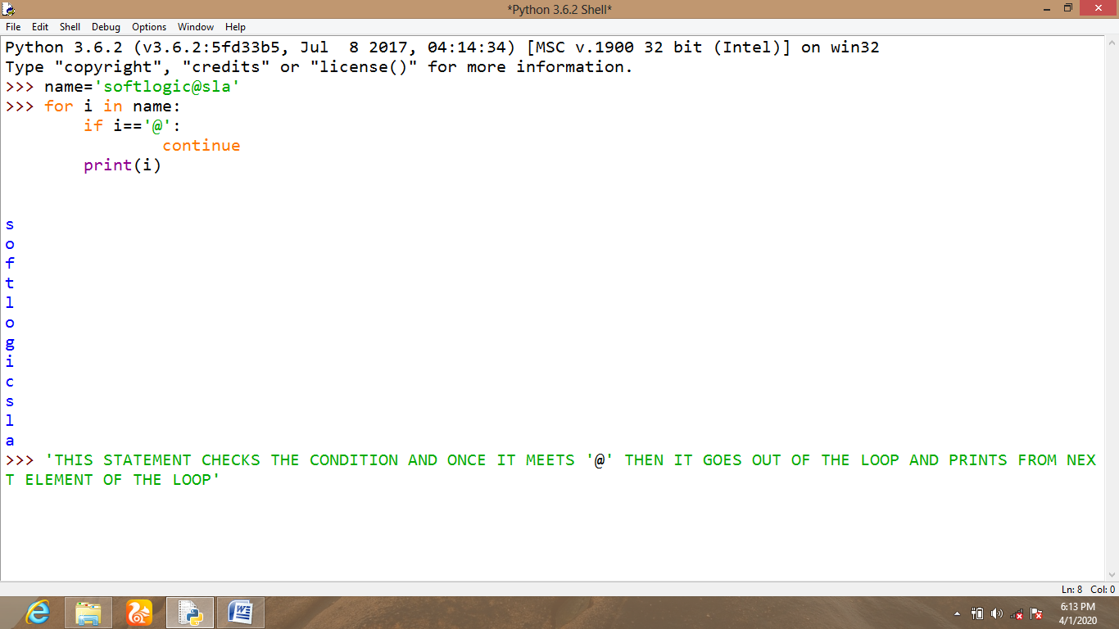
5.1.2. PASS STATEMENT
- Pass statement does nothing instead of closing the opened indentation. But this statement is syntactically expected in a python program.
[NOTE: These flow control statements are commonly used in a python program along with looping statements and decision making statements.]
5.2 DECISION MAKING STATEMENTS
1. IF STATEMENT
2. IF…ELSE STATEMENT
3. IF…ELIF…ELSE STATEMENT
5.2.1. IF STATEMENT
- This simple if statement usually checks the given test condition and prints the value only when test condition is TRUE otherwise it comes out to the terminal.
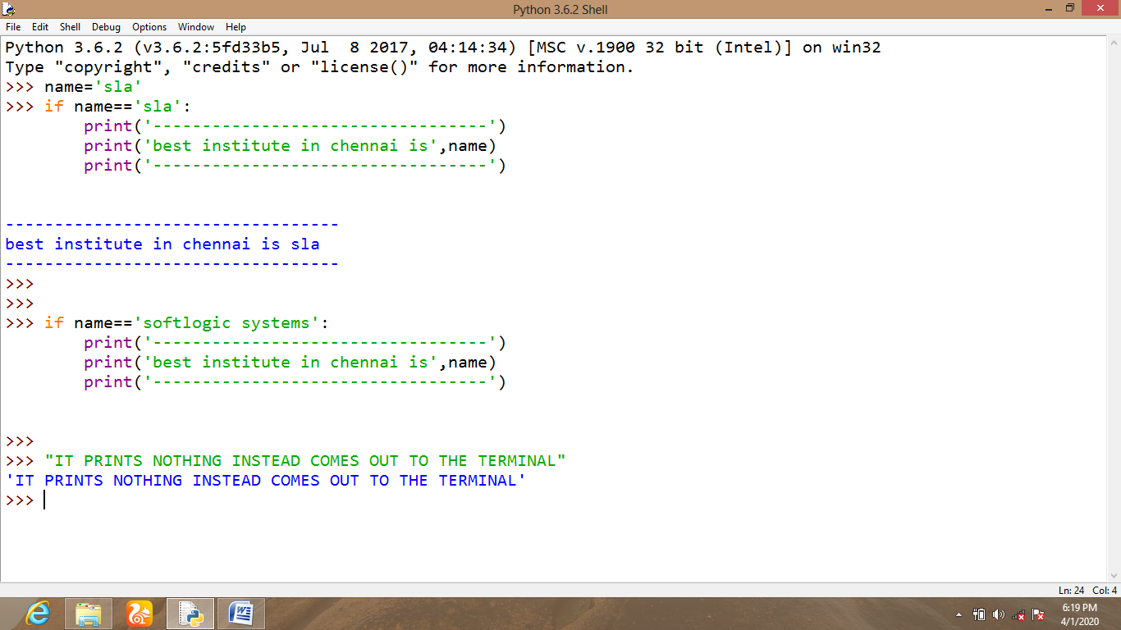
5.2.2. IF…ELSE STATEMENT
- This statement checks the given test condition and prints the TRUE part if condition is met and prints the ELSE part when given condition is not TRUE.
- When working in a new file script of python IDLE, indentation of if and else will remain constant in the same indentation itself.
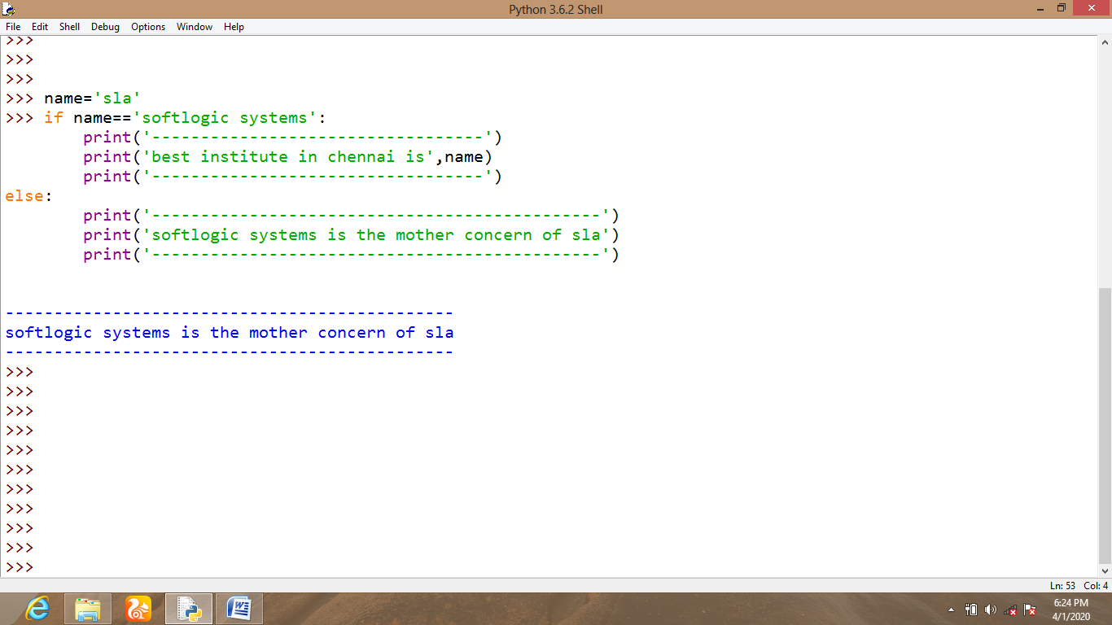
5.2.3. IF…ELIF…ELSE STATEMENT
- This statement is used to apply more than one test condition to the current program to make the current python script checks multiple test conditions at once.
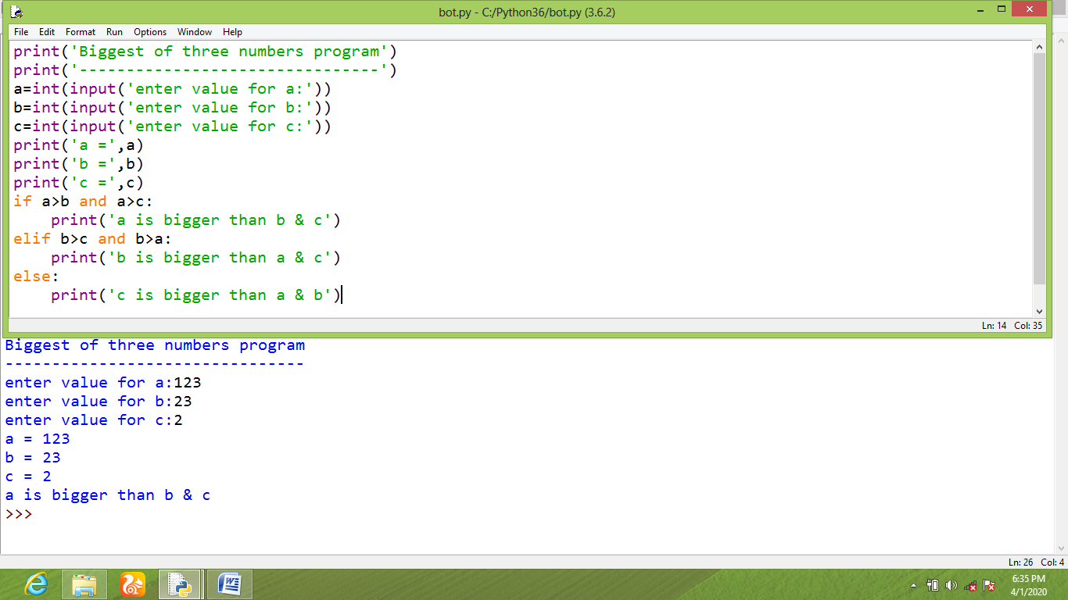
5.3 LOOPING STATEMENTS
1. FOR LOOP
2. WHILE LOOP
5.3.1. FOR LOOP
- This for loop statement will check the given condition only once by taking all the values from the given range and iterates over the loop up to last value of the received range.
- This statement normally iterates the loop up to given condition is fulfilled.
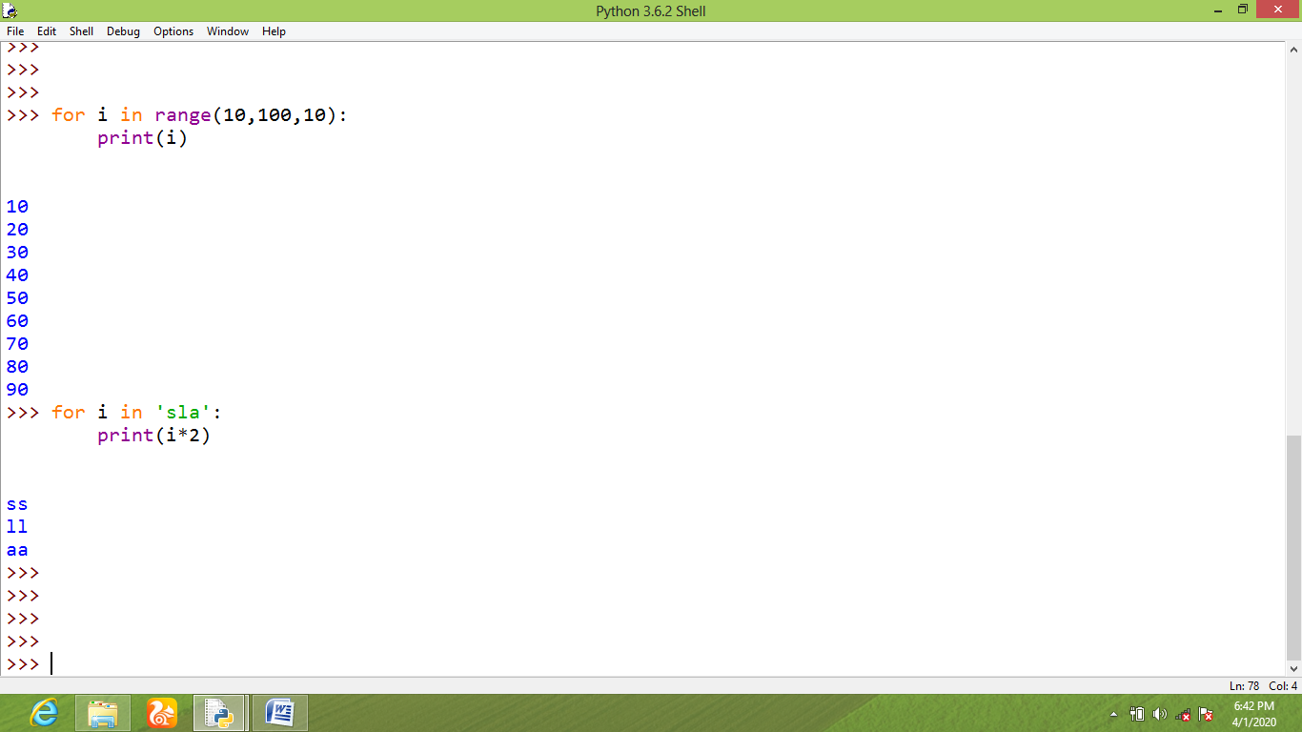

5.3.2. WHILE LOOP
- This while loop checks the given test condition and prints the loop up to given test condition is ‘TRUE’.
- It might have increment or decrement value with in loop iteration otherwise it prints the value infinite times.
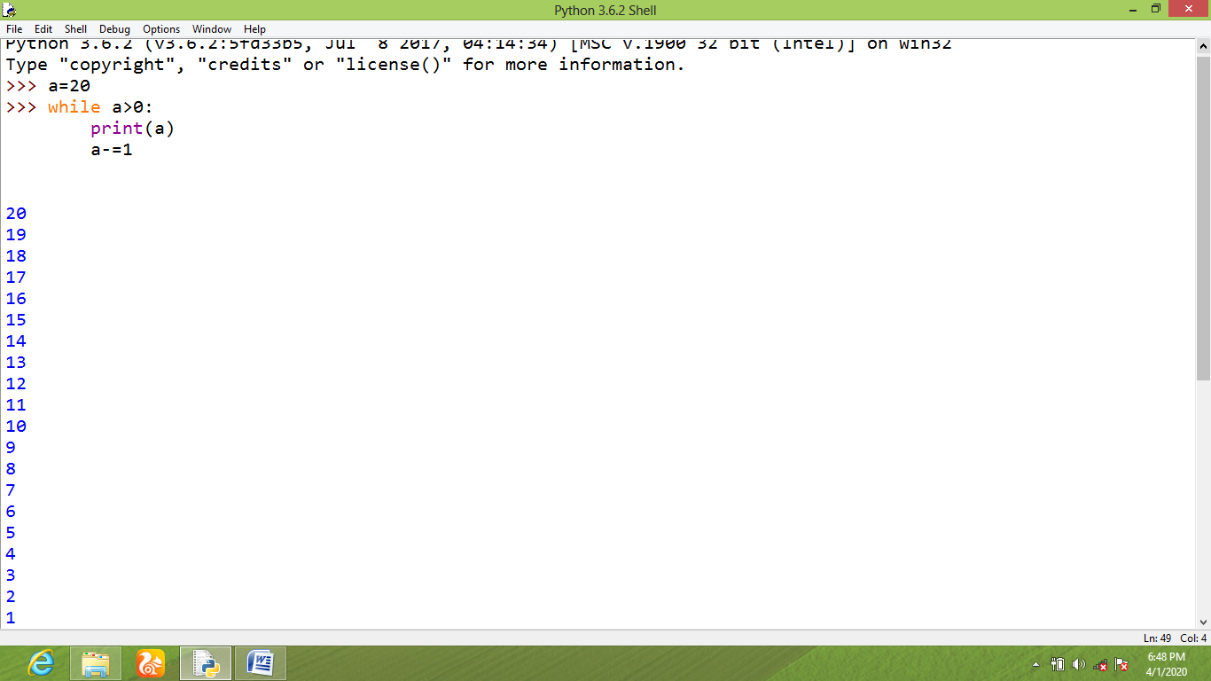
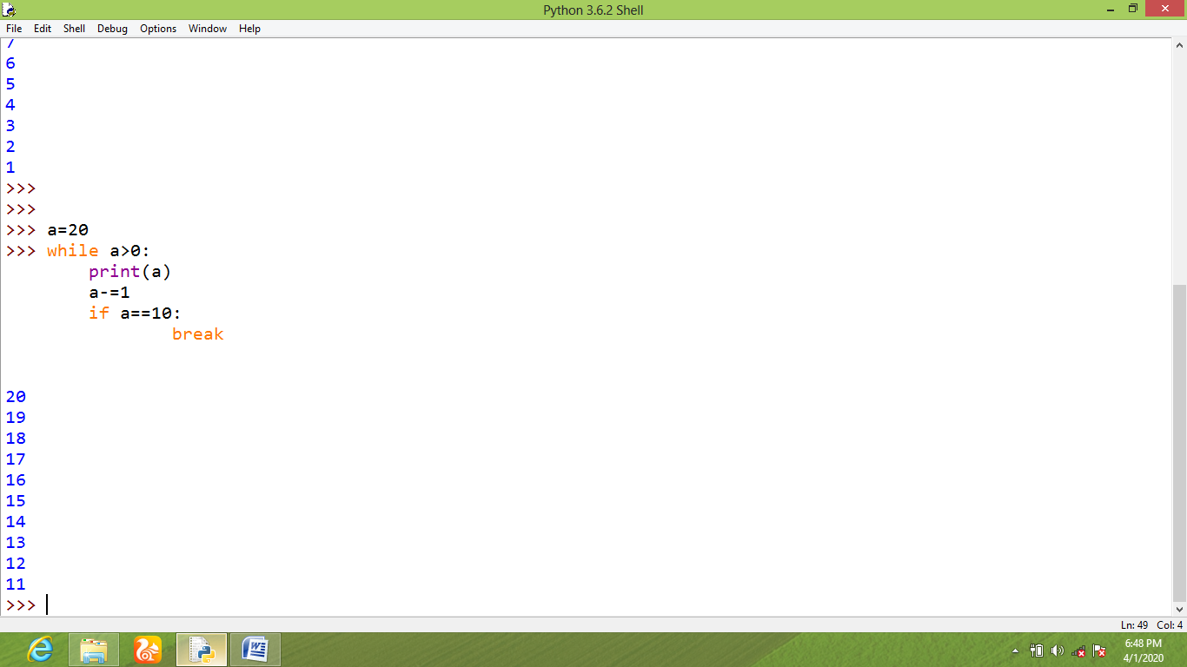
5.4 SAMPLE PATTERN PROGRAMS
